Kol Simcha Torah Gazette
For parsha shemos 5785
Volume 9 Issue 17 (Whole #431) 18 Tevet 5785/ January 18, 2025
Printed L’illuy nishmas Nechama bas R’ Noach, a”h

For a free subscription, please forward your request to keren18@juno.com
Past emails can be found on the website ShabbosStories.com under Brooklyn Torah Gazette

"Oldest Synagogue in the World" Discovered in Russia
By Yehudis Litvak


Art by Sefira Lightstone

An Unexpected Call
Rabbi Menachem Mendel Lazar, leader of the Jewish community in Krasnodar, Russia, never expected to be drawn into an archeological discovery. But when Dr. Vladimir Kuznetsov, head of the Russian Academy of Sciences’ Institute of Archaeology, reached out, his curiosity was piqued.
Dr. Kuznetsov and his team had been excavating the ruins of Phanagoria, an ancient city on the Black Sea, when they unearthed artifacts that hinted at something unexpected: a Jewish synagogue. Unsure of the significance of their findings, the archeologists turned to Rabbi Lazar for guidance in understanding what they had uncovered.
Although the city of Krasnodar is a three-hour drive from Phanagoria, it is the closest Jewish community. Thus, Rabbi Lazar found himself at the archeological site, stepping back in time. “Seeing evidence of a vibrant Jewish community from over two thousand years ago, whose lives and practices were similar to ours today, was truly awe-inspiring,” he recalls. “It’s something I never thought I would experience.”

Ruins of the ancient synagogue in Phanagoria.
The findings revealed much more than just a building. They uncovered a glimpse into the lives of ancient Jews, including a menorah, charity boxes, remnants of an ark that likely housed Torah scrolls, and the likely location of a mikvah.
The findings indicate that the Jewish community of Phanagoria was wealthy and dedicated significant funds toward their house of prayer. The building was large, with wide walls and intricate pillars made from imported marble. Greek inscriptions found in the synagogue list years and names, likely of sponsors who contributed to the building’s construction.

History of Phanagoria
Phanagoria was a bustling metropolis in its time, founded in the 6th century BCE by a group of Greek colonizers from Theos seeking refuge in the wake of Persian attacks on Greece.¹ They named the city after their leader, Phanagorus.
Strategically located between the Black Sea and the Sea of Azov, it thrived as a trade hub with access to major trade routes. “The city reached the height of its prosperity in the 4th c. [B.C.E],” according to the Princeton Encyclopedia of Classical Sites. “Traces of paved streets, wells, water pipes, and basements of rectangular houses with tiled roofs date from this period.”²

The Jews of Phanagoria
The Jewish presence in Phanagoria dates back millennia, though the exact timeline remains unclear. Some historians believe Jews arrived during the Second Temple era, while others suggest they came even earlier, after the destruction of the First Temple. By the early first century BCE, the Jewish community was well-established and had constructed a grand synagogue that reflected their prosperity and dedication.

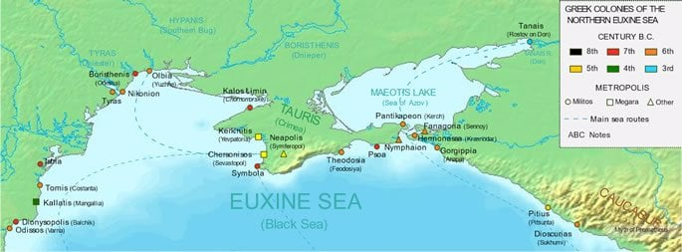
Phanagoria and other Greek colonies on the Black Sea. - George Tsiagalakis

The synagogue was not only a place of worship but also a hub for communal life. Archeologists discovered evidence of two main rooms: one for prayer and another for gatherings and celebrations. Surrounding the synagogue, archeologists found ruins of what they believe to be the Jewish quarter of Phanagoria, with homes, gardens, courtyards with clay irrigation barrels and a water supply system, a winery, and even a large oven that may have been used for baking matzah. In addition, archeologists found over 300 tombstones with Jewish symbols.

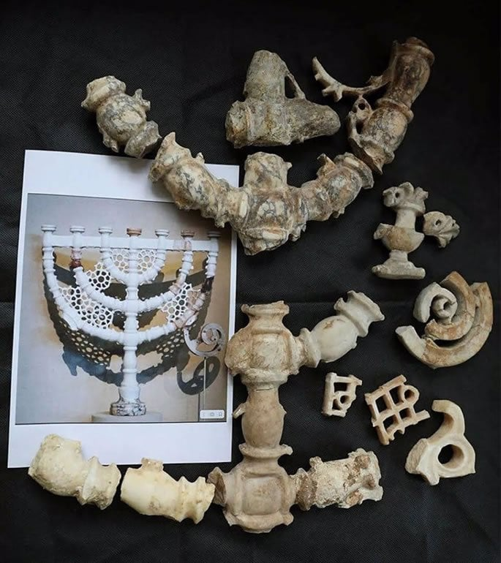
Fragments of one the menorahs found in the synagogue in Phanagoria.

The synagogue's story ended in the 6th century CE when neighboring invaders destroyed Phanagoria. The synagogue and its surroundings were burned, and the city was plundered. Signs of fire are visible throughout the site. Archeologists also found stone cannonballs near the synagogue building. They suggest that perhaps the residents of the city hid inside the synagogue during the invasion.
The Phanagoria synagogue is one of the oldest ever discovered, and the oldest one in Russia. The discovery of the synagogue ruins filled many gaps for historians and anyone interested in Jewish history of this time period. The first stage of the archeological excavation was recently completed, but much more remains to be discovered as researchers embark on the next stage.

A Legacy to Live Up To
For the modern Jewish community in Krasnodar, the discovery of the Phanagoria synagogue is deeply personal. Rabbi Lazar recently led a group to the site, where they stood among the ruins and imagined the lives of their ancestors.
The visit ignited a sense of pride and continuity among the participants. They saw firsthand that Jewish resilience is not just a story; it is their legacy.
“These were proud Jews who built a beautiful, thriving community. Knowing that we are walking in their footsteps is both inspiring and a call to action,” says Rabbi Lazar.

Krasnodar’s Jewish Revival
The modern Jewish community of Krasnodar is itself a story of resilience. Before the Holocaust, Krasnodar was home to a large Jewish community, with a synagogue located in the center of town. Sadly, most of the community was decimated in the Holocaust, and no organized communal Jewish life existed during the Soviet years. Jewish life in the region seemed to fade into history.
Two decades ago, that began to change. Chabad emissary Rabbi Shneur Segal arrived in Krasnodar and began the process of revival. Jewish families started reconnecting with their heritage and forming a community. Rabbi Segal eventually moved to Baku, where he now serves as Chabad rabbi.
Six years ago, the community invited Rabbi Lazar to become their rabbi, and he and his family have been working hard to help the community flourish. Under his leadership, the synagogue and preschool building have been renovated to accommodate more families, and plans are underway to add a Jewish elementary school.
Programs now serve every age group, from preschoolers to seniors, and hundreds attend Shabbat and holiday celebrations. More Jewish programs and institutions are in the works, including a Jewish community center.
“We are hoping to grow,” says Rabbi Lazar. “There is much more to do. We’ve only started.”

From Ruins to Renewal
The Phanagoria synagogue is more than an archeological marvel. It is a symbol of hope and pride for Jews in Krasnodar and beyond. As they uncover their history, they are also writing a new chapter, one of revival, growth, and a deep connection to the timeless traditions that have sustained the Jewish people for millennia.
The ancient stones of Phanagoria may be silent, but their message is loud and clear: Jewish life endures, and its legacy continues to shine brightly.

1. Tsetskhladze, Gocha R, ed. (1998). The Greek Colonisation of the Black Sea Area: Historical Interpretation of Archaeology. Historia Einzelschriften. Vol. 121. Stuttgart: Franz Steiner Verlag.
2. PHANAGORIA Taman. Bosporus.

Thoughts that Count
For Our Parsha

And when she saw the ark among the reeds, she sent her maid ("amata") to fetch it (Ex. 2:5)
As Rashi notes, an alternate meaning of "amata" is "her hand": When Pharaoh's daughter stretched out her hand to reach Moses' cradle, her arm was miraculously increased in length many cubits ("amot"). A question is asked: Pharaoh's daughter could not possibly have known that a miracle would occur. Why, then, did she attempt to rescue Moses in the first place? The answer is that when a person sincerely wishes to help another, he shouldn't stop to think if it "pays" or if it is even feasible. Rather, he must immediately do his part and "extend his hand" to his fellow man. (Rabbi Yitzchak Vorker)

And he spied an Egyptian beating a Hebrew (Ex. 2:11)
Moses could not tolerate injustice against any human being, whether non-Jew against Jew ("an Egyptian beating a Hebrew"), Jew against Jew ("two Hebrew men struggled together"), or non-Jew against non-Jew ("and the shepherds came and drove them away.") (Toldot Yitzchak)

Reprinted from Parshat Shemos 5762/2001 edition of L’Chaim

Rav Avigdor Miller on
How to Love Hashem When One Has a Serious Illness
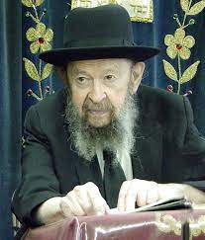
Is it possible to love Hashem with all of one’s heart when chas veshalom he has a severe illness?
And the answer is it's not easy. But it's also not easy to love Hakadosh Baruch Hu when your pockets are full of dollar bills and you're young and you're walking down Ocean Parkway and whistling. You haven't a worry in the world. It's also not easy.
To love Hakadosh Baruch Hu is one of the sciences that require labor, so certainly when his pockets have nothing but holes in them and also his internal organs have holes in them and he's bleeding, let's say, and lying in a hospital, to start then on the derech of loving Hashem is a little bit late. It's like a parachutist who is learning how to make a parachute jump the first time when his airplane cracks up in midair. A little late to start practicing parachute jumping. He should start practicing long before.
However, it's still possible. It's still possible. If you could give this idea to somebody who is dying and tell him look, you're dying anyhow so make use of your last moments to love Hakadosh Baruch Hu and know that it's for your good even though you don't feel it. Love Him anyhow and try to love Him as much as possible and utilize the last moments of your life to accomplish this great achievement. It's something. Maybe a little bit he will.
But the time to practice is when things are going well. Right now, you're young and you're handsome and you still have all of your teeth. Life is ahead of you. You can digest a regular meal. You can walk on your own two legs. You have two eyes. You can still hear. You don't need hearing aids. You're not bent over. So, as you strut out of this place sturdy, stalwart, confident and the blood is coursing through your veins, that's the time to start working on loving Hakadosh Baruch Hu.
There's no time to lose but it's a very important and very big subject. If you postponed until now, so get busy and start studying it and practicing it.

Reprinted from the Parshas Vayechi 5785 email of Toras Avigdor, - (based on Tape #98 – November 1975)

More Thoughts that
Count for Our Parsha

But the more they afflicted them, the more they multiplied and grew (Ex. 1:12)
The literal translation of the Hebrew is actually in the future tense rather than the past: "But the more they will afflict them, the more they will multiply and grow." Indeed, the Torah promises that whenever the enemies of the Jewish people will seek to harm them, their actions will always have the opposite effect. And the greater the persecution and suffering, the more the Jews will ultimately be strengthened and empowered. (Orach Chaim)

But the midwives feared G-d, and did not do as the king of Egypt commanded them (Ex. 1:17)
According to the dictum of "dina d'malchuta dina" ("the law of the land is binding"), a Jew is obligated to abide by the civil laws of whatever society he lives in. However, this is only when the law applies to all citizens equally; it does not pertain to strictures and decrees directed solely against Jews. (Ketzot HaShulchan)

Reprinted from Parshat Shemos 5762/2001 edition of L’Chaim

The Eternal Strength
of the Jewish Soul
From the Teachings of the Lubavitcher Rebbe
Rabbi Menachem Mendel Schneerson, Zt”l

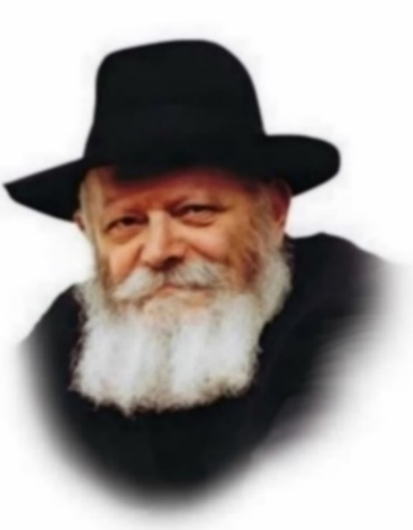
This week we commence the Book of Exodus (Shemot), which begins: "These are the names of the Children of Israel who came to Egypt."
This is not the first time the Torah enumerates the names of the Children of Israel. The sons of Jacob have already been tallied several times in previous chapters. Why, then, does the Torah list their names again?
The Midrash offers two explanations:
Even though they were in exile, the Jewish people did not change their names for Egyptian ones.
The Jewish people are likened to the stars, about which it states, "He [G-d] counts the number of stars; each one He calls by name." Aside from denoting preciousness and value, once something has been counted it can never afterward be nullified.
Chasidic philosophy explains that a person's name relates to his most external aspects rather than his innermost being. (The reason a person has a name is so that others can call him by it; he himself, however, does not really need a name.)
To a certain extent, this describes the Jewish soul after it descends into the physical world and is invested in a body. However, not all of the soul comes down into the physical world: its essence always remains above, united with G-d, while only its external reflection descends to the physical plane.
This is alluded to in the verse "And these are the names of the Children of Israel who came to Egypt." The Hebrew name for Egypt, Mitzrayim, comes from the word meaning constriction and limitation. Only the "name" of the Jewish soul, its outermost reflection, is subjected to the limitations of the physical world and the difficulties of the exile. The soul itself, however, remains unaffected and in full possession of all its powers.
The Jewish soul has never gone into exile. It is not contained or restricted in any way by the physical world, and its essence is always "free." Thus, it is a perpetual source of strength for its reflection down below, enabling a Jew to overcome spiritual obstacles and cleave to G-d in all circumstances and situations.
It was this strength that empowered the Jewish people throughout their years in Egyptian exile, allowing them to remain faithful to their beliefs and retain their original Jewish names. Indeed, this is the connection between the two explanations in the Midrash: the Children of Israel were able to "stay Jewish" in Egypt precisely because the essence of the soul never goes into exile - a lesson that applies to our day as well.

Reprinted from Parshat Shemos 5762/2001 edition of L’Chaim, a publication of the Lubavitcher Youth Organization. Adapted from Volume 3 of Likutei Sichot

Thoughts that Count

But the more they afflicted them, the more they multiplied and grew (Ex. 1:12)
The literal translation of the Hebrew is actually in the future tense rather than the past: "But the more they will afflict them, the more they will multiply and grow." Indeed, the Torah promises that whenever the enemies of the Jewish people will seek to harm them, their actions will always have the opposite effect. And the greater the persecution and suffering, the more the Jews will ultimately be strengthened and empowered. (Orach Chaim)

But the midwives feared G-d, and did not do as the king of Egypt commanded them (Ex. 1:17)
According to the dictum of "dina d'malchuta dina" ("the law of the land is binding"), a Jew is obligated to abide by the civil laws of whatever society he lives in. However, this is only when the law applies to all citizens equally; it does not pertain to strictures and decrees directed solely against Jews. (Ketzot HaShulchan)

Reprinted from Parshat Shemos 5762/2001 edition of L’Chaim
Rabbi Berel Wein on
Parshat Shemot 5784

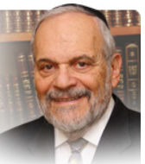

The Jewish people are about to experience centuries of exile and eventual slavery in Egypt. They are certainly in danger of being destroyed both physically and spiritually. The rabbis taught us that by not forgetting their original names, by not completely becoming Egyptian in deed as well, the hope of the Jewish people to be redeemed and freed never died out. The names of their ancestors reminded them of their past and of the commitment of G-d to redeem them from their bondage and afflictions.

This experience of Egyptian exile imbedded within the Jewish world the importance of remembering our original names. For it was the existence and use of those names that prevented their extinction as a special and eternal people. Thus, in the introduction to the book of Shmot, the book of bondage and redemption, is the list of names of the sons of Yaakov, an eternal reminder of who the Jewish people really are.

Over the centuries, the Jewish people have continually struggled to retain their identity and sense of continuity through their names. In the Ashkenazic world it became customary to name children after deceased ancestors. This became a deeply emotional bond in families, ultimately leading to children being given multiple names to commemorate more than one ancestor. In the Sephardic tradition names are given to honor living grandparents and relatives. But, there also the sense of continuity and purpose is stressed in the granting of those names.

In more modern times Jews were given secular names as well to be used in general society. However, over the last few decades the use of exclusively Jewish or Hebrew names has become in vogue once again. So apparently there is a great deal involved in a name. Even in the non-Jewish world, the use of biblical names remains quite popular and widespread. People hunger for a connection to their past and such traditional, biblical, family names seem to provide a sense of immortality and continuity that flashy “cool” names cannot provide.

Names can therefore be an anchor to one’s own self-worth and purpose in life. The Torah’s insistence on recording the names of the sons of Yaakov – the eventual tribes of Israel – highlights this important fact of life and family to us. Perhaps this is what Midrash meant when it taught us that one of the causes of the redemption of Israel from Egyptian bondage was “that they [the Jewish people] did not change their names [from Hebrew ones to Egyptian ones.]”

Reprinted from the current website of rabbiwein.com

Pharoah and the Jewish Midwives

The midwives said to Pharaoh, ‘Because the Jewish woman are unlike the Mitzrayim woman’. (1:19)
Pharaoh came to the midwives with a complaint - ‘I told you to kill all the Jewish boys that are born. Why haven’t you followed my instructions? After all Jews believe that one must follow the laws of the land where you live’.
“So, the midwives answered the Jewish woman are unlike the Mitzrayim woman - you are applying this law only to Jewish woman. the obligation to follow the laws of the land only applies in Jewish law when the laws of the land are applied to everyone - not just to the Jews.
Pharaoh’s response was Pharaoh commanded to all his people saying ‘Every son that will be born - even a Mitzri - into the river shall you throw him’. We have no choice but to apply this decree to Mitzrim as well. (Ktzos Hachoshen)

Reprinted from the Parashat Shemot 5785 email of R’ Yedidye Hirtenfeld’s whY I Matter parsha sheet for the Young Israel of Midwood in Brooklyn.

How Jewish is Too Jewish?
By Leah Grossman

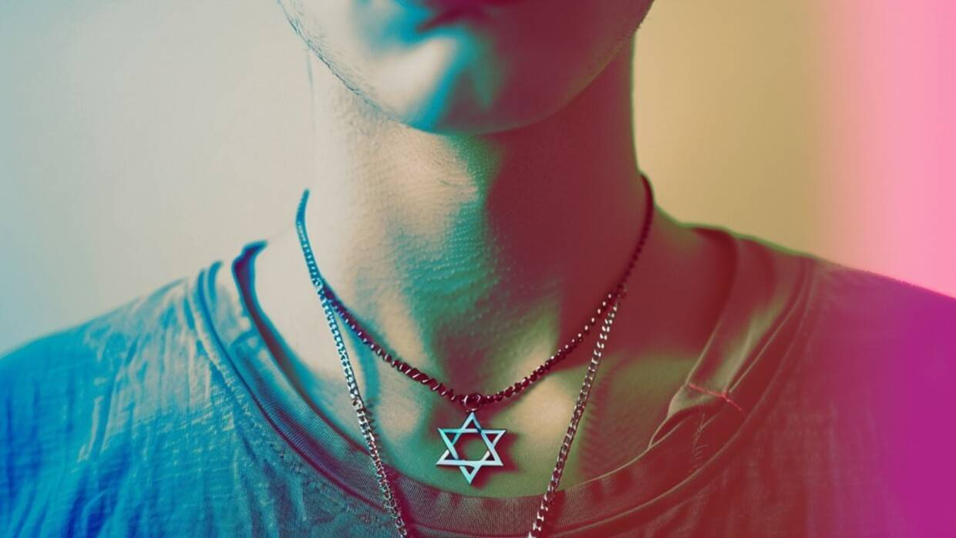

With antisemitic violence and harassment at an all-time high, it’s a scary time to be a Jew. But you know what feels even scarier? Being a silent one.
Like so many others, I’ve found myself with a renewed connection to my Jewish identity post-October 7th. Sure, I grew up going to Hebrew school and Jewish summer camp. I became a bat mitzvah and felt comfortable parading around our synagogue as the cantor’s daughter. But I never shouted my Jewishness from the rooftops. So why do I feel compelled to do that now? It’s pretty simple, really.
Because it feels like my life depends on it.
With antisemitic violence and harassment at an all-time high, it’s a scary time to be a Jew. But you know what feels even scarier? Being a silent one.
Being silent means agreeing with all the lies being told about us. It means accepting what’s happening around the world as normal and okay. It means signing our own death warrant.
I never thought we would be here—I went the first 40 years of my life without experiencing a hint of antisemitism. Yet, the notion of history repeating itself now feels more like a foregone conclusion than an abstract idea.
Can’t they see this is how it started? And how easily it escalated into total disaster when nobody cared enough to speak up? We have a blueprint of what this situation can turn into, and I think I speak for all of us when I say: no thank you. I refuse to accept that fate for myself and for my children. I refuse to be silent out of respect for my late grandfather, his tattooed numbers etched in my memory as permanently as they were etched onto his arm. Never again.
So where does this leave me in practical terms? Every day I wake up and see more discrimination, bias, and violence against Jews than any other group would ever be expected to tolerate. And I find myself asking the same question: how much can I speak up about it without alienating the people around me?
Silence isn’t an option, as we’ve already established. But if I go overboard, will my friends (and hopefully allies) start to ignore me? Will they begin to gloss over the content or even hit the unfollow button as I try to convey the pain and injustice we’re facing on a daily basis? Exactly how many cute photos of my kids and dog will balance the scale? It feels like a bad version of One Bid from The Price is Right—stand up for yourself as much as you can without going over! Precisely how Jewish am I allowed to be?
Those on the other side seem to have no qualms about proclaiming their hate loudly, both with their words and actions. They call for a violent intifada, shatter the windows of Jewish-owned businesses, set fire to our synagogues, and hunt us down in a premeditated pogrom. So why is there such deafening silence on the side of the good guys? Why are we letting the bullies run the show?
I’m enormously grateful for the accidental activists who’ve emerged since October 7th—they’ve saved my sanity during this horrific time. But we need more. We need more people who aren’t afraid. We need more people who have moral clarity and the chutzpah to speak up. We need more Elphabas.

Do You Support Israel’s War?
A friend recently asked me if I support the war and the way Israel is fighting it. I stopped in my tracks, completely thrown by the question. Do I support the war? You mean the one we didn’t start, never wanted, and would end tomorrow if they simply returned the hostages? The one that if we don’t fight, we’ll be all but conceding to another October 7th (or worse)? We’re fighting for our survival, there is no alternative.
Do I support the way Israel is fighting? Like how they’re dropping leaflets and making phone calls to warn civilians to evacuate? How they’re being meticulously strategic to avoid civilian casualties? Tell me what other army would do this and still receive worldwide criticism. We know a thing or two about genocide (the word was literally created to describe the Holocaust). If that’s what we intended to do here, we’re really bad at it. (And G-d forbid anyone criticize Hamas for hiding among civilians, stealing aid, or refusing to return the hostages to end the war that they started.)
The bias is clear, the double standards are plentiful, and the propaganda is effective. I’ve seen even the most well-intentioned ally have their heartstrings tugged on by an artistically beautiful Faces of Gaza photo essay, swept up with so much sympathy they felt the need to repost it. They don’t understand that even this seemingly benign post translates to one very clear message, same as all the others: blame the Jews. They don’t think about the people who may see this and choose to act on it. They don’t realize it poses a very real threat to our families, or how the security guards at my kids’ (Jewish) school now carry massive machine guns on a daily basis. They don’t know when I share photos of my children, I crop out the school name embroidered on their uniforms…just in case.
Being a Jew is special. We’re good people—do I even have to say that? But we are. We believe in peace and tikkun olam (repairing the world). We give tzedakah and perform mitzvot. We contribute positively to society and support other minorities in their time of need. We pray together. Celebrate simchas together. Grieve together. We have an inherent shared experience of resiliency in the constant fight for our survival as 0.2% of the world’s population and the crime of being born a Jew.
While they call for intifada and tear down American flags, we gather hand in hand to sing Hatikvah, call for the return of the hostages, and pray for peace. Can’t they see we’re the good guys? Why are we the last people on Earth to earn the world’s sympathy and understanding, even behind terrorists? I will never understand.
It all feels like a bad dream I can’t wake up from. I want the hostages to come home and the war to end. I want people to stop being taught to hate us from birth. I want to go back to worrying about mundane things that have no bearing on my right to exist. I want to remember what life was like before.
Until then, I’ll pray good triumphs over evil. I’ll hope more people will seek the truth and speak up for us. And I’ll keep being a proud Jew, for there is no other path I could ever choose.

Reprinted from the current website of the aish.com website. A version of this op-ed was originally published on The Times of Israel

